Iris data set -there are no missing elements in the data set

- The data represented is nominal

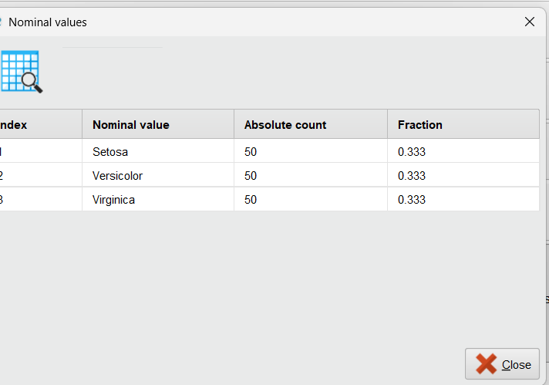

German credit data

This is a nominal data set woth no missing values

